

**HMRC Goods Vehicle Movement Service (GVMS) – Haulier communications – Goods Movement Reference (GMR)**

**Audience**

These communications have been produced to inform hauliers or their delegated third parties of the following GVMS topics:

1. **GMR completion** – your responsibilities and liabilities.
2. **GMR issues when checking-in** – how to avoid these by ensuring your GMR is finalisable
3. **Check if you need to report for an Inspection Service** –a reminder around how this service works and why it is important to use it

**GMR Completion – your responsibilities and liabilities**

**Responsibilities / liabilities and GVMS - declarants**

Declarants have a legal obligation to pre-lodge declarations if they are moving their goods through a location using GVMS and pass evidence of this for a haulier to complete a GMR.

When moving goods through a GVMS port any corresponding customs declaration made into CHIEF or CDS must include the additional Information code ‘RRS01’ which identifies the declaration to GVMS – failure to do so will result in relevant declarations not being arrived into or departed from the UK.

**Responsibilities / liabilities and GVMS - hauliers**

Hauliers have a legal obligation to carry evidence that pre-lodged customs declarations or reference numbers for Simplified Customs Procedure authorised traders are in place for all the goods they are moving.

This is met by hauliers carrying a GMR which must include a declaration reference for each consignment as proof that a pre-lodged declaration has been made.

HMRC reserves the right to apply penalties if these obligations are not met by traders and hauliers.

Carriers will require a valid GMR to be presented at the port of departure before allowing the vehicle or trailer to board.

**What to enter in a GMR**

The party responsible for completing a GMR (usually a haulier but can be a 3rd party acting for a haulier such as an agent) must enter references/declarations to cover all the goods/consignments contained in either the vehicle, trailer, or container.

You should always refer to the guidance page [“Get a Goods Movement Reference”](https://www.gov.uk/guidance/get-a-goods-movement-reference) on GOV.UK to confirm which customs reference types should be included for your direction of travel.

To support that guidance please refer to the important information in the table below.

|  |  |
| --- | --- |
| **Movement type** | **Important information** |
| Imports declared either into Customs Handling of Import & Export Freight (CHIEF) or Customs Declaration Service (CDS) | Each consignment covered by an Import declaration must be individually entered into the GMR – for example if your load is made of multiple consignments with relevant customs declarations, you should enter all those declarations individually.  Failure to do will result in the customs declarations not being “arrived” correctly on entry into Great Britain (GB) or Northern Ireland (NI). This would require manual action by the declarant or agent. This remedial action may be costly for the declarant**.** |
| Entry in Declarants records where authorised traders declare into their own records using Simplified Customs Declaration procedures | When moving goods for authorised traders who have made a declaration into their own records, you must only enter the GB EORI into the GMR for the goods being imported by the Simplified Customs Declaration authorised trader. The authorised EORI must be used for this purpose only.  Any other consignments that make up the remainder of your load, must always be covered by the appropriate declarations (e.g., CHIEF ERN’s, Transit MRN’s etc) or other Simplified Customs Declaration Procedure authorised EORI’s. These must be included individually in the GMR. |
| CTC Movements (EU>GB or GB to NI) | If moving under Common Transit Convention (CTC) you must enter the Transit Accompanying Document (TAD) Movement Reference Number (MRN) or MRN’s to cover all goods moved under the CTC. Any other goods not covered by a TAD must be entered separately in the GMR with a reference for the appropriate customs procedure the goods are being moved under.  Please note you should not enter any Import declarations from CHIEF or CDS that may be required to discharge the transit procedure and “arrive” the goods. This action should not be carried out until Office of Destination processes are completed and must be completed outside of GVMS |
| CTC Movements (Exports GB>EU) | You must ensure that in instances where you do not enter a Declaration Unique Consignment Reference (DUCR) and can enter a TAD instead, the TAD MRN/MRN’s must cover all the consignments on the vehicle.  Any consignments not covered by a TAD must include the appropriate reference or DUCR. |
| CTC Movements (general in all directions) | For CTC movements always ensure the Office of Departure processes, including any control actions, are completed and that your movement has been released before you enter the TAD MRN into the GMR.  If you enter a TAD MRN for a movement that has not been released (which typically takes around 20 minutes) GVMS will invalidate the transit declaration for the movement. To remedy this the trader would need to submit a new transit declaration to re-start the transit movement before the goods could be moved to the UK. This would need to be done at an Office of Departure or Authorised Consignor |
| Combined Customs and Safety and Security Exports declaration (DUCR) declared into CHIEF or CDS | Each consignment covered by an Export DUCR (unless being moved via another customs process such as a TAD or TiR/ATA Carnet) must be individually entered into the GMR – for example if your load is made of multiple consignments with relevant customs declarations, you should enter all of those individually.  This will confirm the goods have legally left the UK and provide a notification/record to declarants to this effect.  If you receive a GMR status of ‘inspection required’ for your GB-EU export movement, you should check with the declarant what checks need to happen before the goods are given permission to be exported. Some checks can be done at the trader’s premises, but in some cases, you will need to attend an Inland Border Facility or a port’s designated customs checking facility.  If you are moving through a location that needs an arrived export declaration, you must not proceed to the border location of departure until you have confirmation that all the goods have Permission to Progress (P2P). |
| Declarations by conduct and empty vehicles, trailers, containers | If you wish to move goods under oral or conduct declarations you must ensure these meet the criteria detailed [here](https://www.gov.uk/government/publications/list-of-goods-applicable-to-oral-and-by-conduct-declarations) and complete a GMR if you are moving through a [Border Location](https://www.gov.uk/guidance/list-of-ports-using-the-goods-vehicle-movement-service) that has adopted GVMS.  If you are moving commercial vehicles trailers or containers that are empty, you will also require a GMR.  You must not use the procedures above for any reason other than as described unless you have been explicitly advised to do so by HMRC as an exception. |

**Note: HMRC reserves the right to apply penalties to both declarants and hauliers if the appropriate customs obligations discussed above are not met.**

**If you have concerns**

If you have concerns around non-compliant or fraudulent activity this can be reported via the following page <https://www.gov.uk/government/organisations/hm-revenue-customs/contact/report-fraud-to-hmrc>

**Avoiding issues at check in and embarkation of GMR**

HMRC are aware of several instances where GMR’s have errors and have not been correctly finalised when presented for check in before travel.

This has caused issues where customs declarations have not been arrived/departed, which is a legal requirement, or transit procedures not being correctly adhered to. This has also caused instances of GMR’s being flagged for customs inspections that are not required.

To avoid this, you must ensure your GMR is in a complete state before it is presented at check in with your carrier. You can check this by logging into the GMR dashboard and confirming if your GMR has any errors (as per the example below).

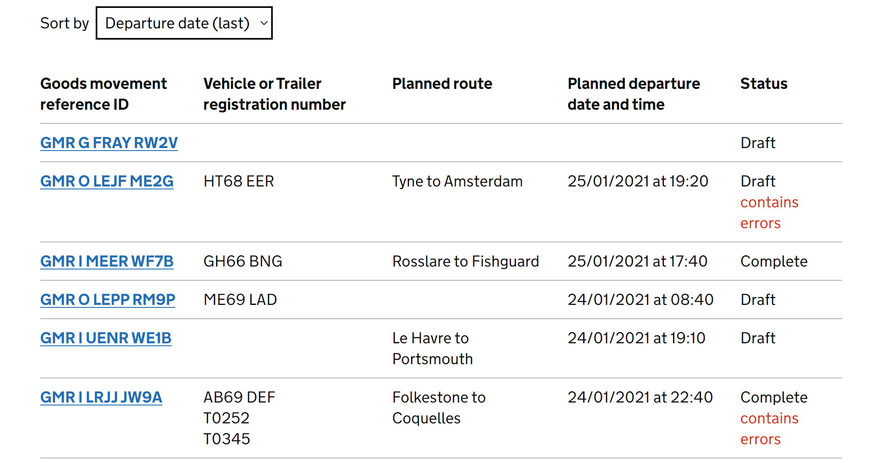

If you see any errors, you must click into the GMR and correct these before checking in with your carrier. Failure to do so may cause delays in the clearance of goods through customs and may require remedial action by the declarant.

**Check if you need to report for an Inspection Service**

HMRC recently issued a communication to confirm the “[Check if you need to report for an Inspection Service”](https://www.tax.service.gov.uk/driver-inspection-notification/start) has been updated to provide more information around where you can report to if an inspection is required. You may be directed to an Inland Border Facility (IBF) for documentary or physical checks of your load if these checks cannot be done at the border.



The service allows drivers or any party with access to the service (via a smartphone or device with internet access) to check the inspection status of their goods before the crossing has completed.

No access to a Government Gateway account or GVMS is required, just a link to the service and the GMR ID.

When moving goods into GB or NI it is important that hauliers/drivers check this status 10 minutes before disembarking the vessel to ensure they are aware of any inspections required.

The haulier and/or driver may be liable to a penalty of up to £2,500 if they fail to follow HMRC instructions to report for an inspection.

It is the responsibility of the person who created the GMR to ensure that the goods arrive at importation for inspection at a port or an IBF if instructed to do so, and that their drivers are made aware or have the means to check if an inspection is needed.